CULTURAL ACTIVITIES 2021-22
- In connection with Vigilance Awareness Week -2021, Essay Writing and slogan Writing Competition conducted by Vigilance Department, SCCL on occasion of Azadi ka Amrit Mahothsav.
Our Students got I,II & III Prize
Kum.Divya, I BZC – I Prize
Kum.Yashwanthi, II MSCS – II Prize
Kum. Soundarya, III MPCS – III Prize
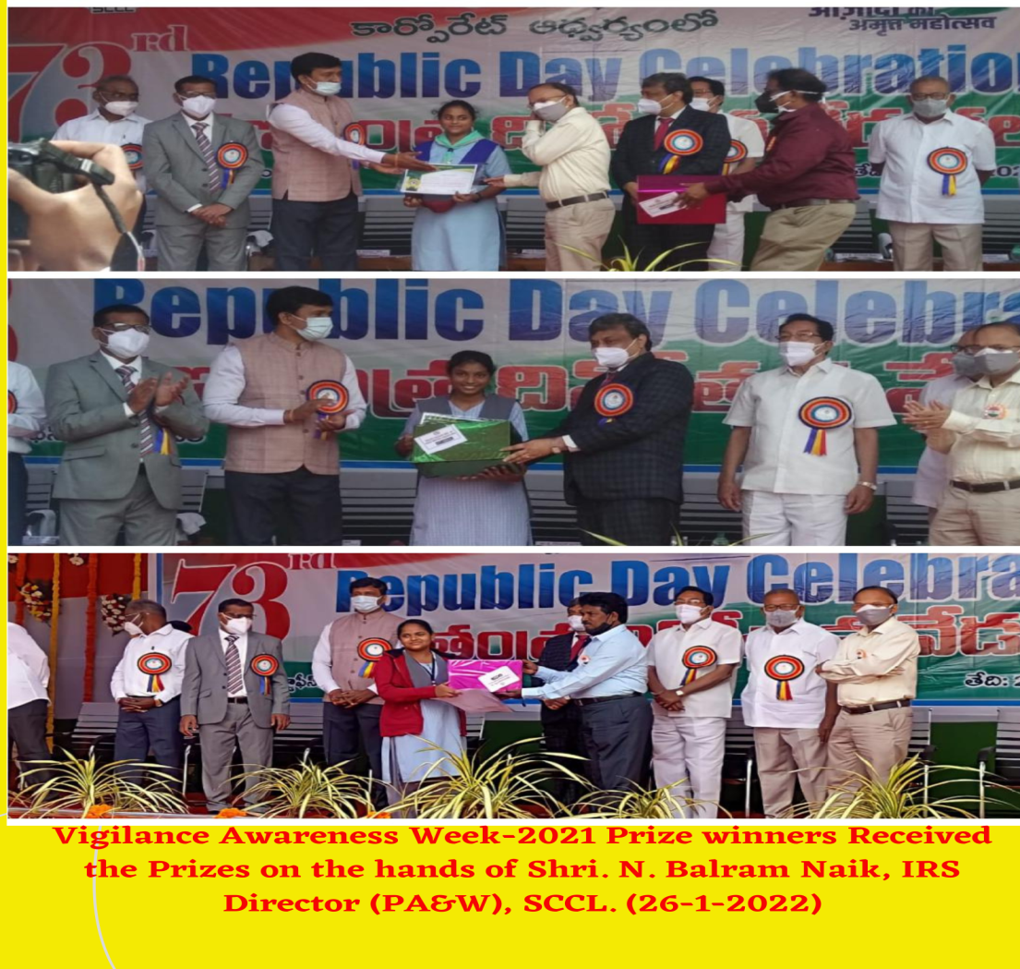

- Our Student Geethika, I M.Sc (Computer Science) participated Kuchipudi Dance performance in R-Day Parade in Delhi 73rd Republic Day Celebrations at Rajpath, New Delhi.



 